Project Name

PROJECT CHARTER
TEMPLATE

Date: dd / mm / yyyy
Version: 1.0
Prepared by: X.YYYYYYYYY
PROJECT CHARTER

Project Name
Project Sponsor(s)
Proposed Start Date
Proposed End Date

- Project Background and Rationale
- Describe the business rationale for the project, providing relevant background information to help the reader of this document place the proposed project in the right context (e.g. relative to strategic or operational goals of the company).

- Project Goals
- What is the overall project goal or objective?
- Specifics under deliverables, scope, success criteria should help ensure the objective is "SMART" and clearly understood by all. (Note: to help simplify a charter, you could also group goals, deliverables success criteria together into one section).

- Deliverables
- What are the key outputs / end products of the project? (Be as specific as possible: e.g. a new process, a report/presentation, a system implementation, a recommendation etc.)

- Scope
- What are the boundaries of the project? Provide information that may help scale the project and specifically address topics raised by stakeholders in terms of what is included vs. excluded from the project. What is described here may be helpful later on when issues of "scope creep" may need to be addressed!

- Success Criteria / Expected Business Benefits
- May include project benefits or specific measures associated with quality of outputs, project process etc.

- Proposed Timeline & Key Milestones
- Specify the proposed timeline and the important milestones either in text form, or (better) using a graphical timeline so that readers of the document can quickly understand the proposed timing.

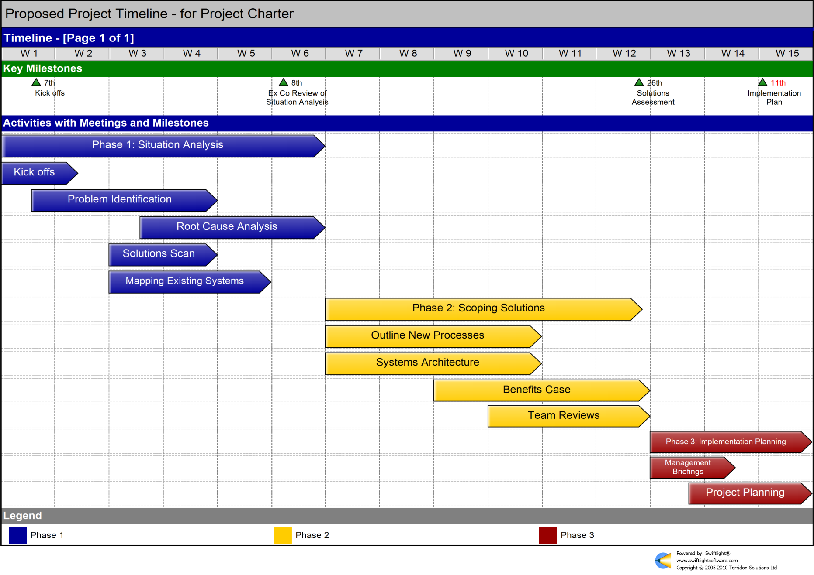

- Resources & Organization
- List the key people, groups and organizations / teams that will be involved and contributing to the project.
- Sometimes an organization chart may be helpful.

What | Who | Role / Comments
Project Sponsor(s)
Steering Committee
Project Manager
Team Members
Other

- Assumptions
- List any assumptions that have been made in developing the project charter, focusing on those which may have a significant impact on the project if the assumption proves to be wrong.

- Risks
- Identify all known, potential issues / risks that may affect the project. Consider developing a risk management plan for significant risks. (Note: there is sometimes an overlap between assumptions and risks (i.e. a risk could be an assumption that proves to be incorrect). If it makes better sense for your project, just merge the Assumptions section into the Risk section).

- Budget
- Estimate of approximate cost of the project (Man / days & financial cost). Fuller costs are often worked up during detailed project planning.

- Reporting
- Provide an overview of key reporting processes / meetings – perhaps using the table below.
- A more detailed communications plan can be worked up in the Project Plan if needed.

 | What | Audience | Frequency | Responsible
Meetings | Steering Committee Meetings | Steer Co, PM, PMO | Monthly | PM
Meetings | Key Stakeholders | TBD | Start, middle, end of project | TBD
Reports | Status Reports |  | Weekly | PM

- Authorizations
 | Name | Signature | Date
Approved By

